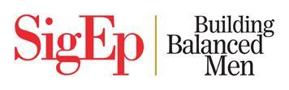

**Do you exemplify the qualities of**

**a Sound Mind & Sound Body?**

**Have you been a leader in & out of the classroom?**

**Are you a Balanced Man with a 3.0+ GPA?**

**If so, you may qualify for the Cleveland State/SigEp**

**Balanced Man Scholarship**

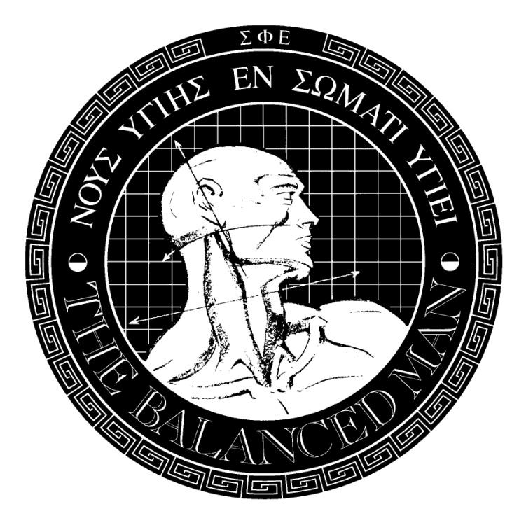

Scholarships totaling $ 2,600 are available to freshmen male students

attending Cleveland State University in the fall of 2022

Apply online by August 15, 2022 by accessing: [www.clevelandstate.sigep.org](http://www.clevelandstate.sigep.org)

Then click on the Balanced Man Scholarship sliding panel

For information, contact: Adrian Amer | [adrianamerirl2002@gmail.com](mailto:adrianamerirl2002@gmail.com)

or: Aaron Glowacki | [aarontheman@120@gmail.com](mailto:aarontheman@120@gmail.com)